Projuct Report Template

**Irevolution: A Data-Driven Explortion Of Apple’s Iphone Impact In India**

**1. INTRODUCTION**

**1.1 Over Viwe**

The world has changed as a consequence of the increasing use of smartphones, which have improved communication, connected people, and revolutionized many different businesses. With its main product, the iPhone, capturing markets around the world, Apple Inc. has emerged as a prominent player among the top smartphone makers. India, one of the economies with the greatest economic growth, has seen a tremendous increase in smartphone usage, making it an interesting market to study the effects of Apple's iPhone.

**1.2 Purpose**

In order to shed light on important factors like market penetration, customer preferences, economic ramifications, and societal changes, this research report will perform a data-driven investigation of the impact of the iPhone in India.

**2. Problem definition and design thinking**

**2.1 Empathy map**

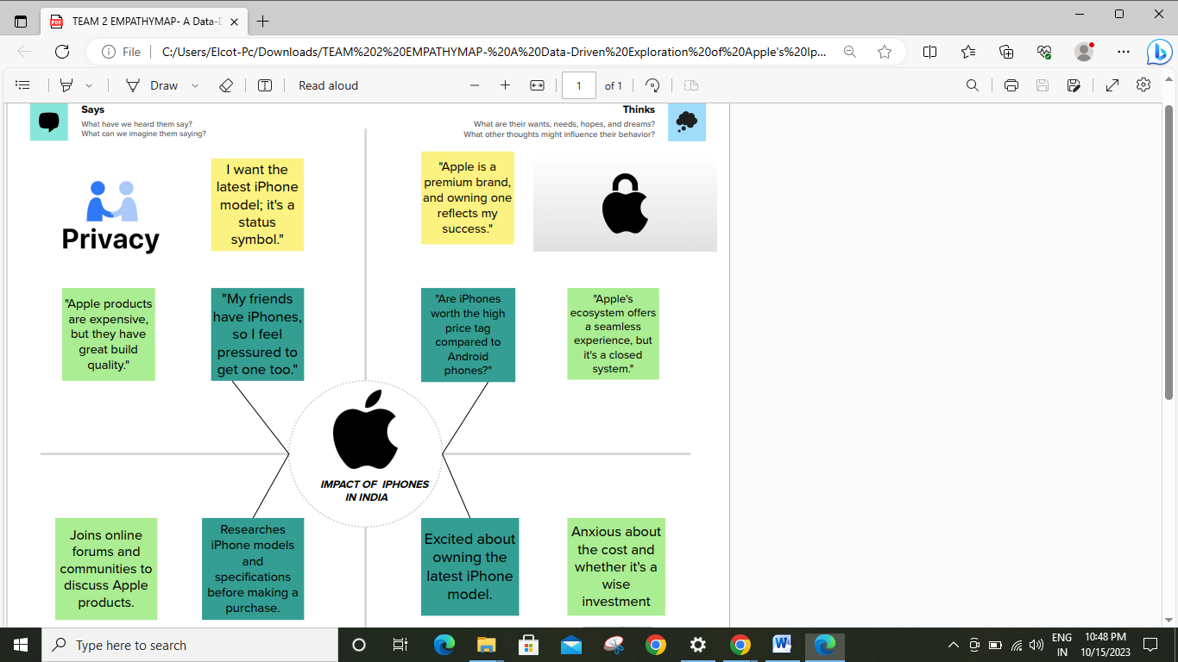

2.2 Brain Stroming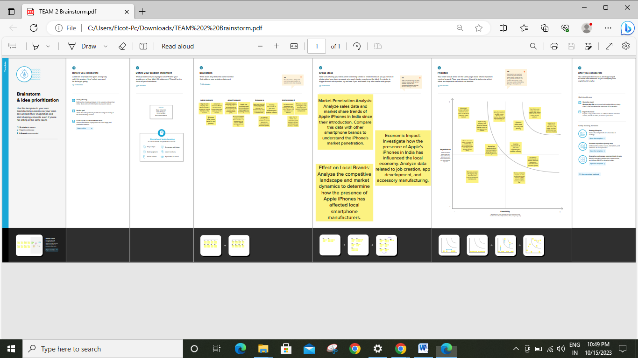

3. RESULT

**3.1 Dashboard 1** 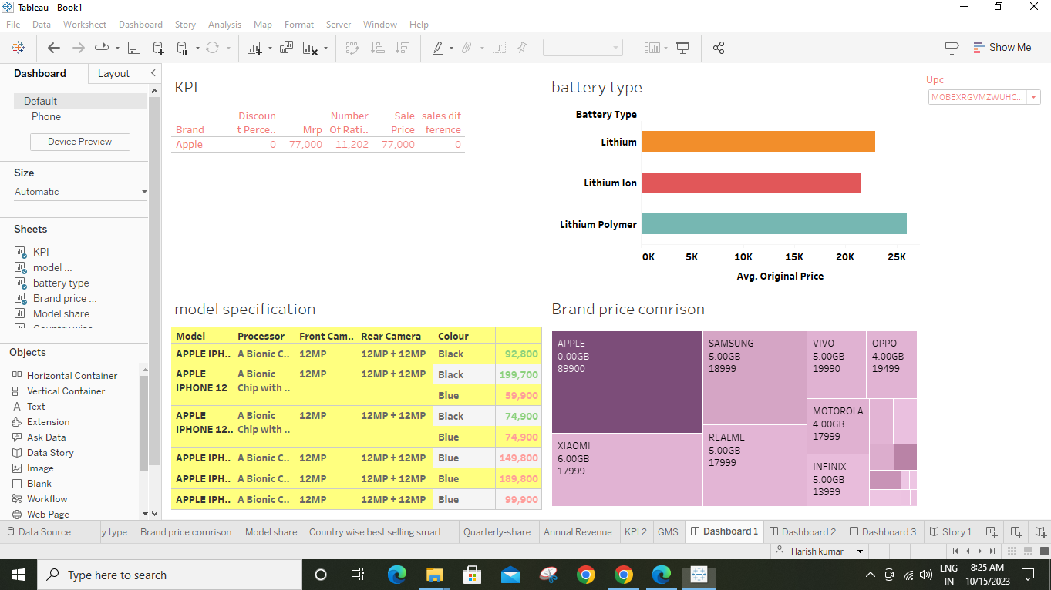

**3.1 Dashboard 2**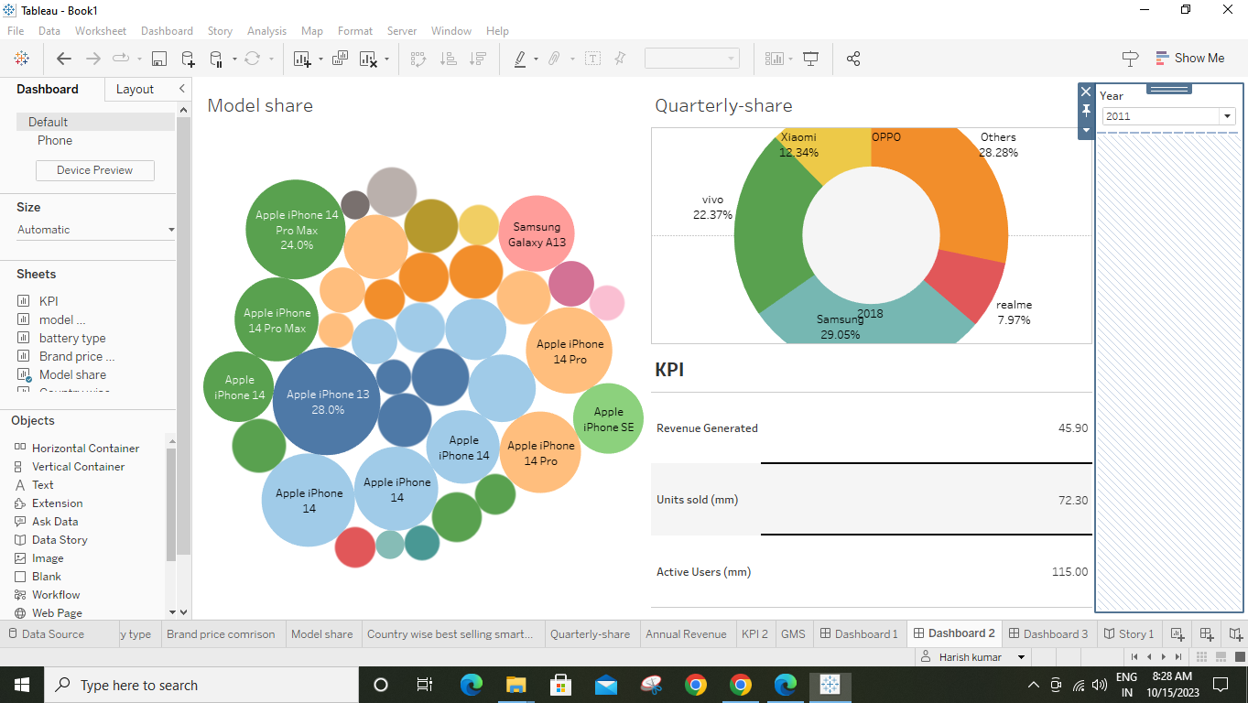

**3.1 Dashboard 3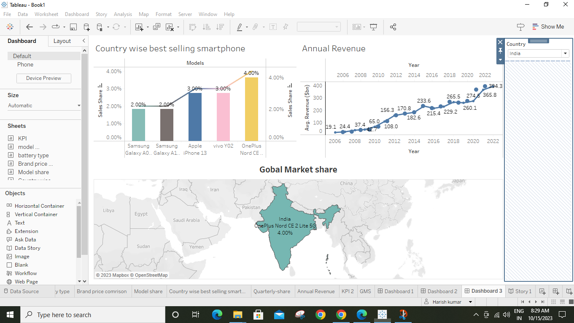3.2 Story** 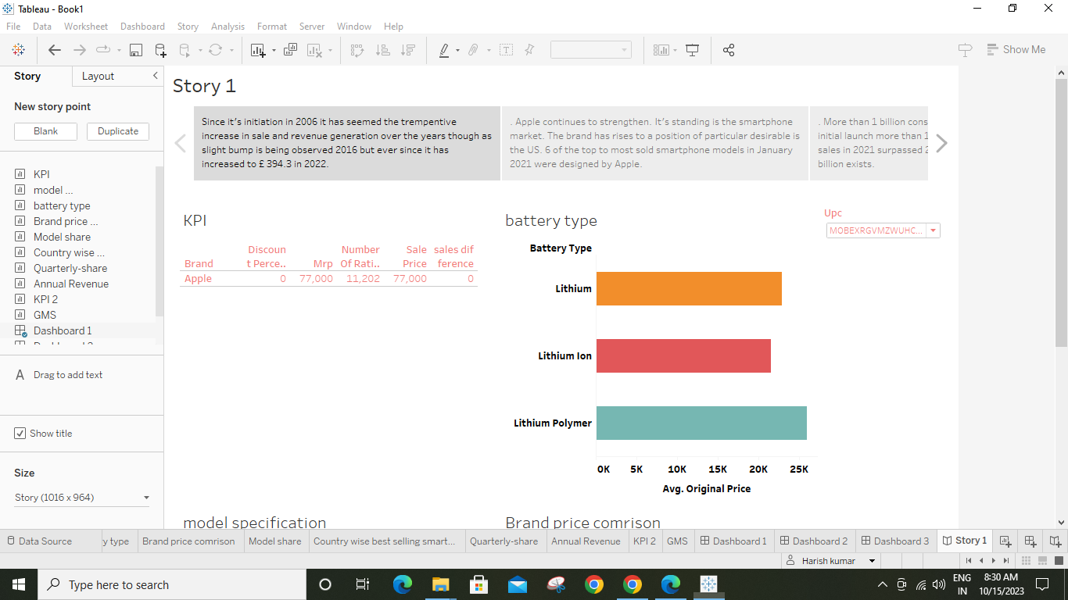

**4. Advantage & Disadvantage**

**Advantage**

In order to shed light on important factors like market penetration, customer preferences, economic ramifications, and societal changes, this research report will perform a data-driven investigation of the impact of the iPhone in India. This study will offer invaluable insights into the transformative impact of the iPhone on India's technological landscape and the lives of its consumers by using advanced data analytics techniques and analyzing large datasets.

**Disadvantage**

Apple has a special chance to increase its market share and develop a significant presence in India thanks to the country's large population and rising smartphone adoption. Each new iPhone model unveiling generates excitement and anticipation among Indian buyers. By utilizing the plethora of information

Already accessible, this research aims to go beyond conjecture and anecdotal evidence in order to develop a thorough knowledge of the effects of the iPhone.

**5. APPLICATIONS**

Fast software updates for many years: The biggest advantage iOS has over Android is its software updates: Apple generally supports new iPhones and iPads with iOS updates for five to six years after their release date, and all of those devices get the same updates at the same time.

6. CONCLUSION

Apple created a very strong overall marketing strategy for the iPhone and managed every aspect of

the iPhone’s launch very effectively. Like almost all products, the iPhone has some flaws and drawbacks,

but Apple was able to develop a unique product for tech-savvy consumers interested in a combination

smart phone-music player and make those customers aware of the product through well-managed

marketing efforts and strong publicity. The iPhone exemplifies Apple’s knack for creating excitement

about products among its fiercely loyal customer base, who keep attention focused on the company, and

then justify the hype by delivering a high-quality, desirable product. In addition to satisfying consumers

with a great product, Apple built a powerful partnership with AT&T and also conferred benefits to overseas

suppliers of parts and manufacturers. All of these efforts boosted Apple’s stock price considerably and

further solidified Apple’s image as a leader in consumer electronic gadgetry.

**7. FUTURE SCOPE**

The above said in terms of technology is ever changing and evolving. The mating between hardware and software is optimal. iOS development has a bright future, as iOS is the most preferred platform where most of the Internet of Things (IoT) get complete compatibility and support. Moreover, ultra modern home automation apps are getting developed using iOS only.

The things changes drastically, if not given attention, it is difficult to handle the upcoming challenges.

Apple is one of the biggest companies in the smartphone world and has a very strong user base which is ever growing and will keep doing so. The future of the iOS developers are going to be very bright and this market going to boom in coming years.

However, one should keep in mind that in the market other than iOS developers there are other ways to develop iOS apps, like cross-platform app development using Xamarin and PhoneGap.

The more technological awareness is expected for the development of the iOS applications. iOS developer should be well versed in not only iOS but also have the profound knowledge of Car Play, Watch OS, Apple TV and all. With some experience on front-end technologies.

Especially, for the iOS developers, with the more experience, the more technological awareness is expected, including the skills of native app development for example iOS, Android, etc with cross-platform and hybrid app development.

This will keep development only on the safer side, also different from the mob, giving an edge in the competition. If developers are learning and enjoying work, then they can easily switch to other technologies and master them in less time.